Legal entities in scope: DBAG, ExR, EFAG, ECAG, CBL, CBF, CS, CI, LuxCSD and CFCL

L2 Monitoring Systems and Reporting

Organisational structure

DBAG
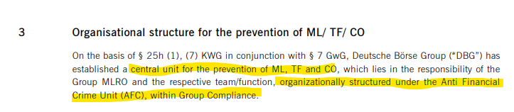
Framework_AML_CTF_OCO.pdf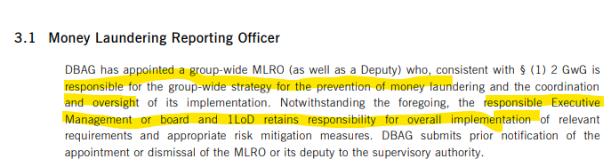
Framework_AML_CTF_OCO.pdf
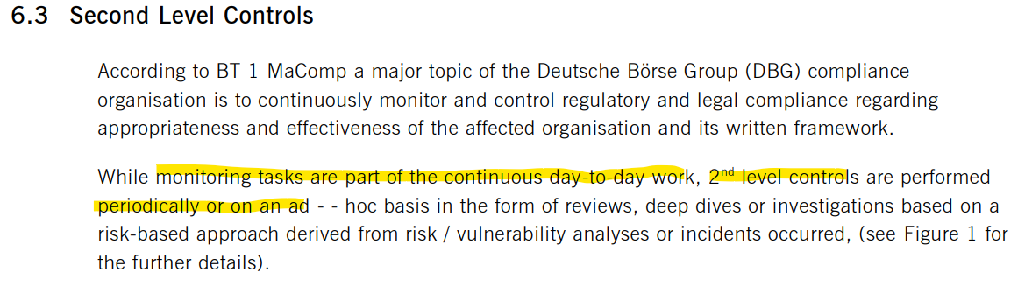
Framework_AML_CTF_OCO.pdf
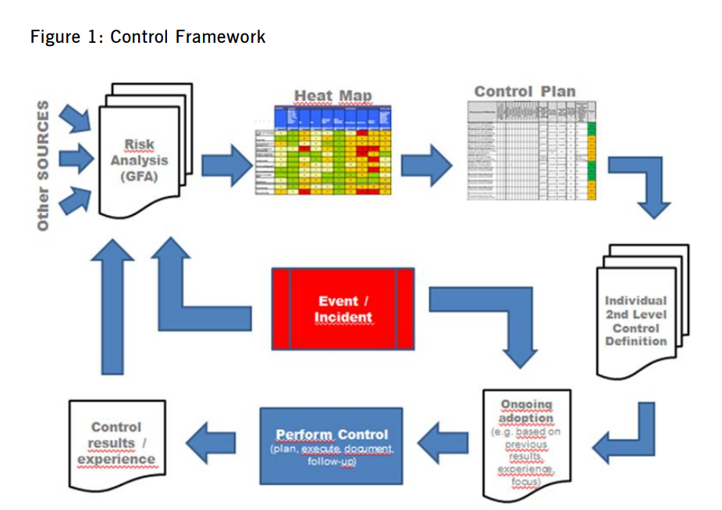
Framework_AML_CTF_OCO.pdf
What about continuous monitoring?

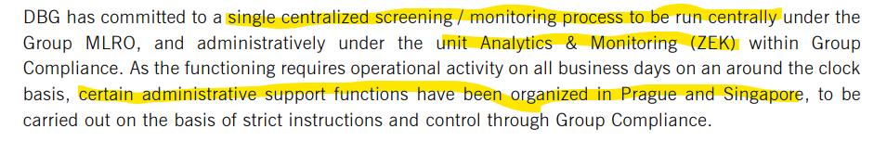
Framework_AML_CTF_OCO.pdf, Page 11

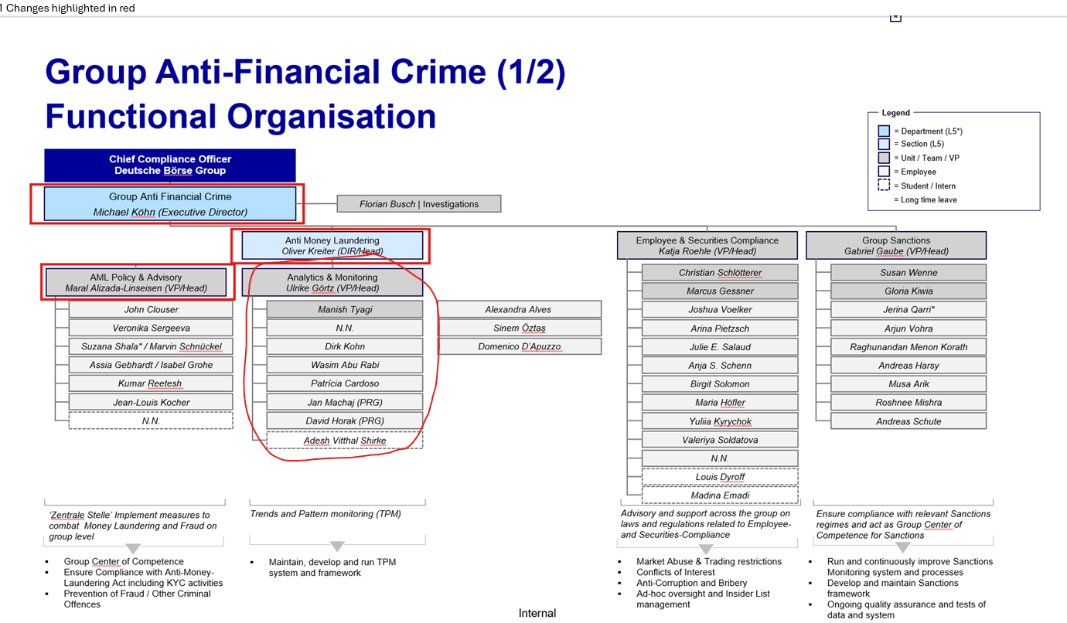

Where do the 3 employees floating fit in? They are part of GC directly under Oliver Kreiter.
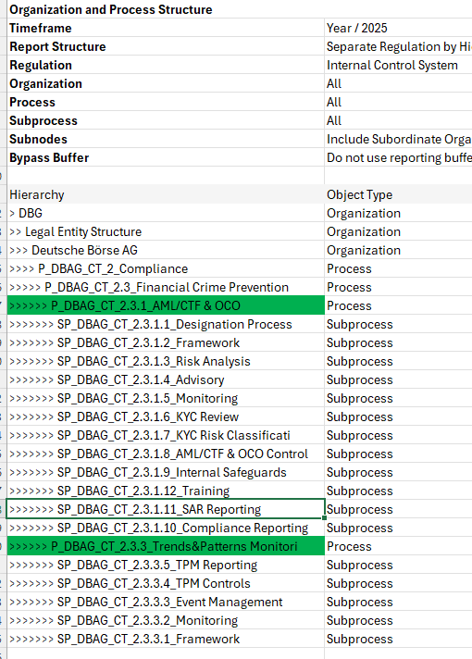

CBL
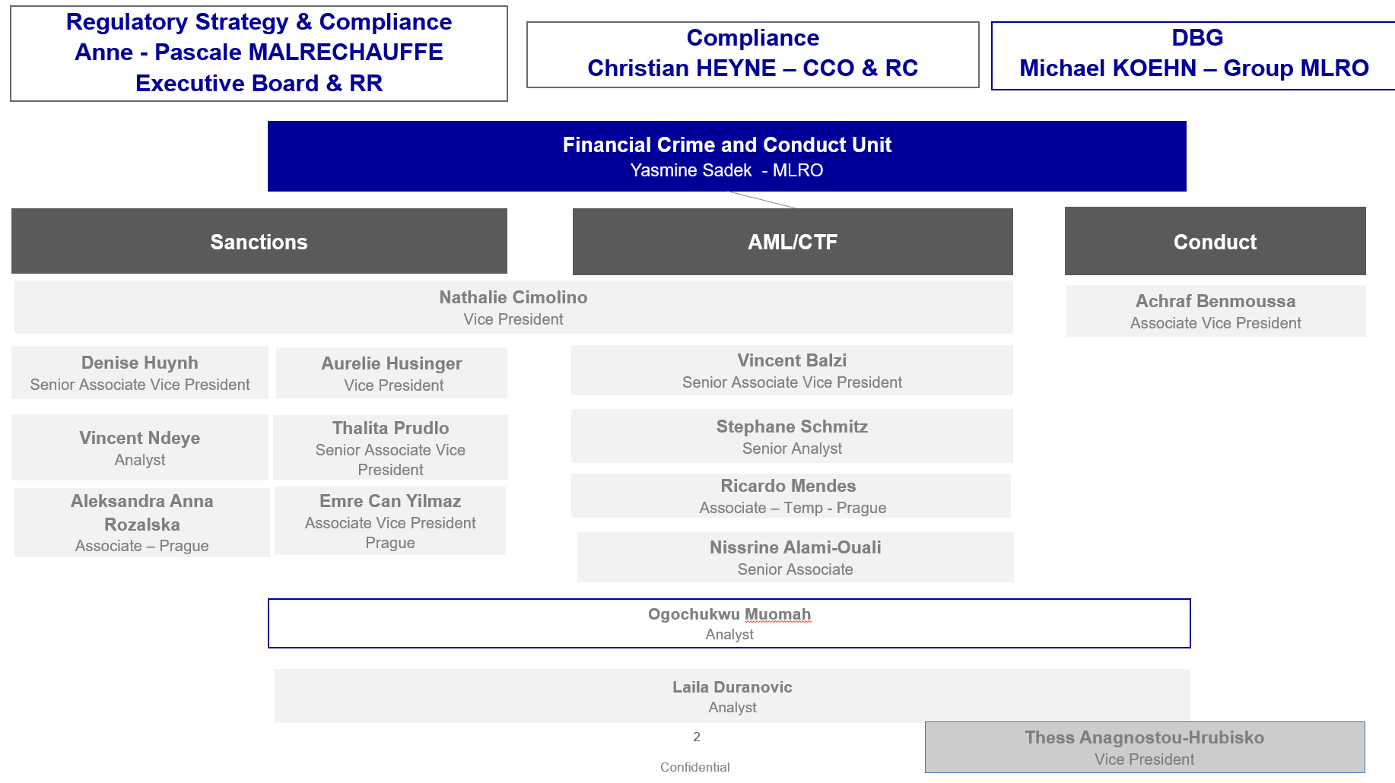

Restructuring FCC Roadmap_Target Operating Model_vFinal.pptx
Only 4 employees allocated to AML topics. Sufficient?

CFCL
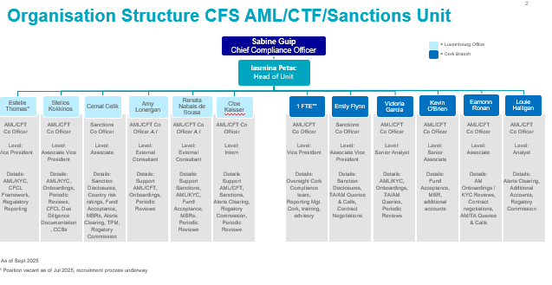

Employees in Lux and Cork

Outsourcing

DBAG & GER
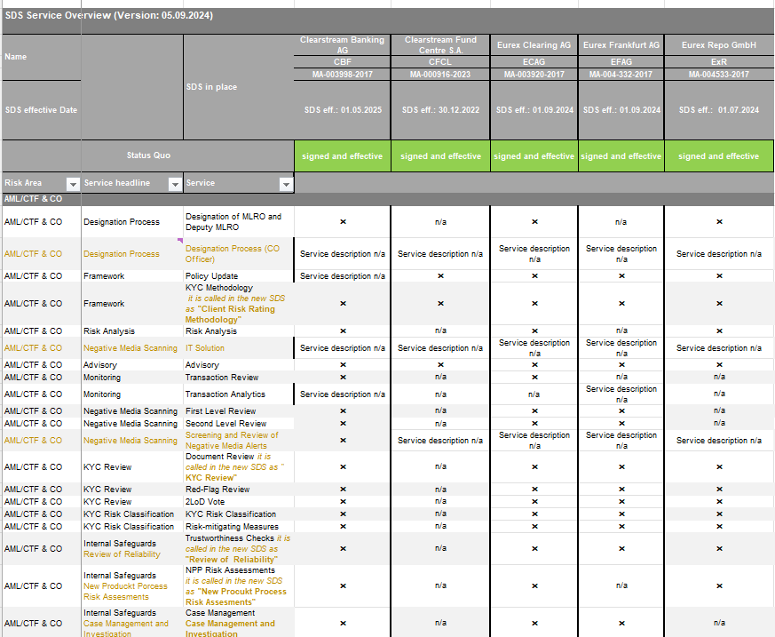
SDS Service overview_(old SDS Master Template) ExR-ECAG-EFAG-CBF-CFCL.xlsx

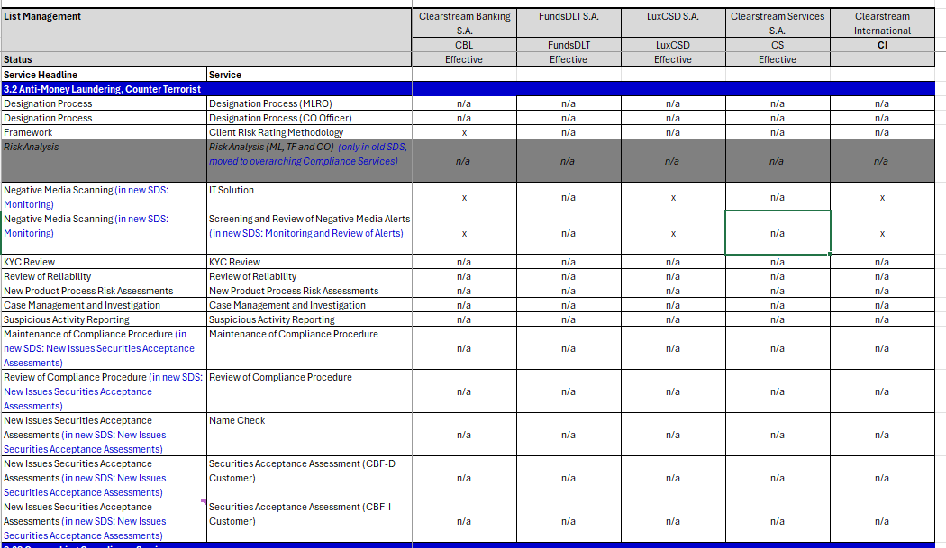
SDS Service Overview - New Master Template 20250806.xlsx

- There is an Excel file called new New Master Template for Clearstream LUX; is there a new version for GER too and what are the changes of the new template?
- What is the difference between Monitoring Transaction Review and Analytics?
  - Transaction analytics is not performed by DBAG for CBF, ECAG, EFAG, ExR, CFCL. Why not?
- EFAG does not outsource NPP risk assessment to DBAG
- ExR and CFCL do not outsource classroom trainings to DBAG; are they performing their own?
- Where is sub-outsourcing of TPM activities to e.g. Prague and Singapore reflected? No SDS obtained?

Clearstream LUX
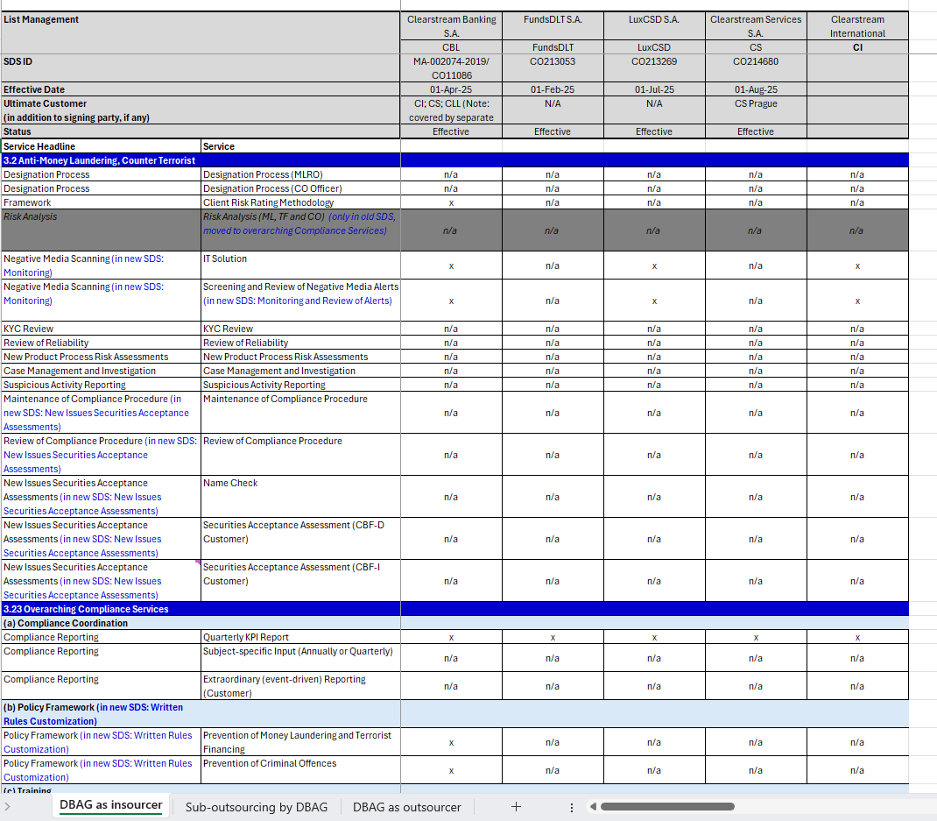

CFCL
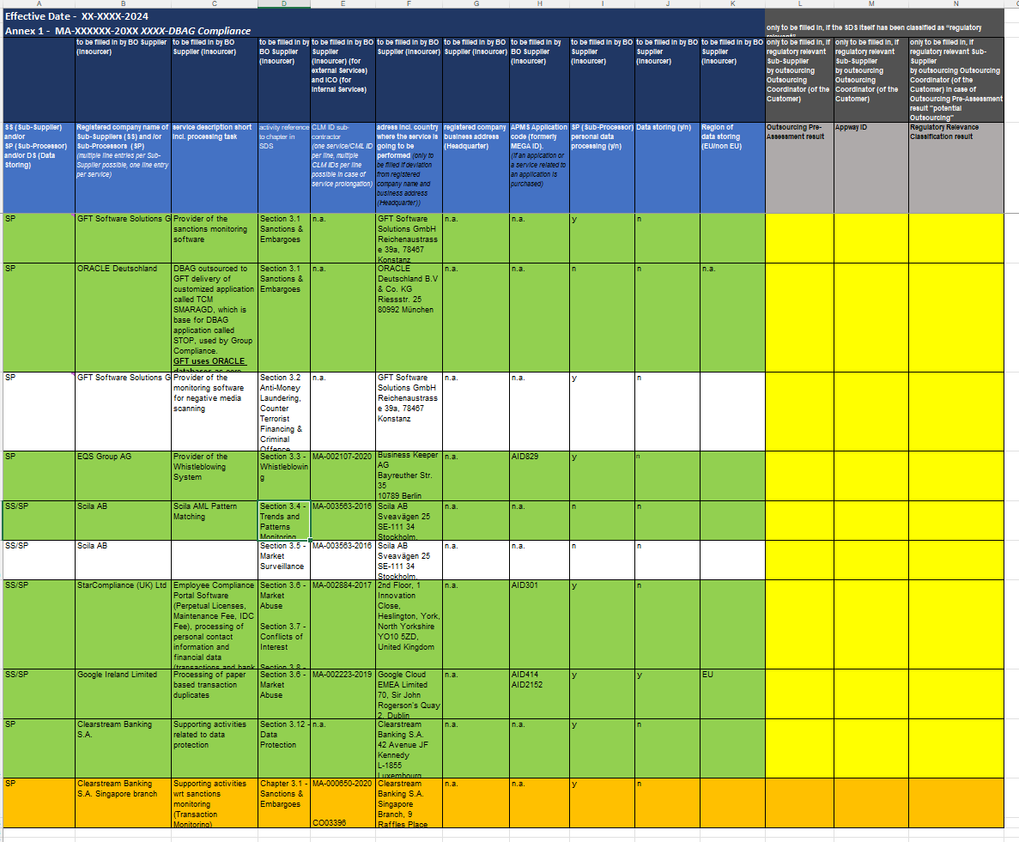

CFCL currently is performing their TPM manually; onboarding contract to DBAG TPM signed and planned for Oct/Nov 25
Employees in Lux and Cork
Refer to CFCL:
- No TPM so far; risk limited as settlements only commenced in 2025 (no of transactions etc TBC during fieldwork)
- Risk was communicated to Boards, Committees, Regulator
ECC own system

Questions
- Why is CH not in scope, particularly re new AMLR effective 2027 as obligated entity given the 3 year audit plan?
- Ensure each LE with AML requirements has an MLRO; is there a functional reporting line of all AML employees to the senior AML officer?
- Sufficient expertise/training of MLRO and team?
- Where do we cover 2LoD controls of 1LoD?

L3 Pre-product, Clients, Assets and Transactions Screening/Monitoring, Trends and Patterns Monitoring (TPM)

L3 Details
- Pre-product refers to the MCP Assessments (for ECAG: particularly regarding services where cash can be transferred between clearing members (e.g., position transfer, give-up), requests from irregular client)
- Clients, Assets and Transactions Screening/Monitoring are covered via the Trends and Patterns Monitoring (TPM) which other ways are
- Understood as continuous monitoring as opposed to SAR/STR which represents 2nd level controls via periodic and/or ad hoc monitoring

DBAG & GER
- Reporting to GCC? Framework_AML_CTF_OCO.pdf, p 11-12
- According to SAR Reporting Process.pdf, p. 14 any SAR must be monitored more intensively by Analytics & Monitoring Tool
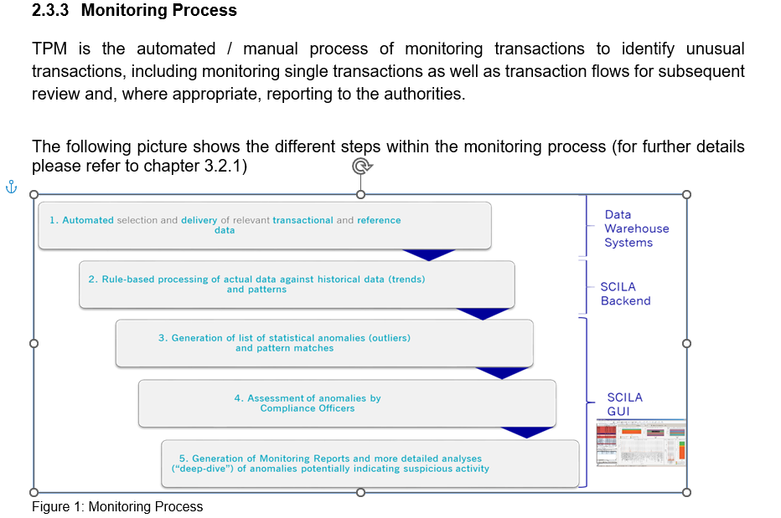
TPM_GOV_Procedure_Oversight.docx

AML Analytics & Modelling (ZEK) identified the following challenges in their presentation to IA on 22/08/2025:
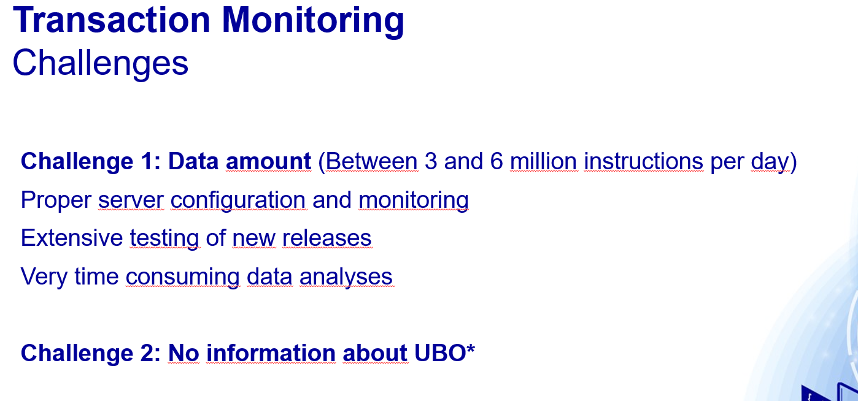
TransactionMonitoring_InternalAudit.pptx
How are those challenges addressed and are they potentially issues?
IA obtained the following information during a phone call on 05/09/2025 with Dimana Plamenova Mabhena (Compliance Officer, 1LOD) and Jan Machaj (Compliance Officer, 2LOD Analytics & Monitoring):
Data amount
This is not an issue but merely a fact and the reason why Scila was chosen; Scila can handle huge amounts of data.
Dimana confirmed that there are no delays or data issues when performing TPM in Scila.
No info about UBO
Dimana confirmed that the UBO (Ultimate Beneficial Owner) is not available as part of TPM; monitoring stops at client level, which are bank who are also trading on behalf of other banks
KYC might have certain information, e.g. UBO of a particular client
To say who is the last UBO is not possible also due to data protection on the banking side.
Jan confirmed that
- for P and M accounts the UBO is known, however, UBO = bank;
- for A accounts the UBO not known as
  - Ominibus (NOSA)
omnibus accounts could potentially be excluded from monitoring as information is not known
  - For segregated accounts the UBO might be known
Who creates accounts for clients Dominice Cole

Do we have any safeguards in place that the bank confirms that their trading members are okay? Yes, potentially in COM, however, we rely on clients information.
Also, UBO might be known on trading side but due to Chinese Walls information is not allowed to combine data.

Data feed to Scila
All source systems Statistix Xeops upload Scila
Exception: CBF or CBL have a direct access, potentially for Corporate Events (ask Dirk Kohn, Patricia Cardoso)

Clearstream LUX
Policy on the Prevention of Money Laundering & Terrorist Financing
Policy on the Prevention of Money Laundering Terrorist Financing.pdf

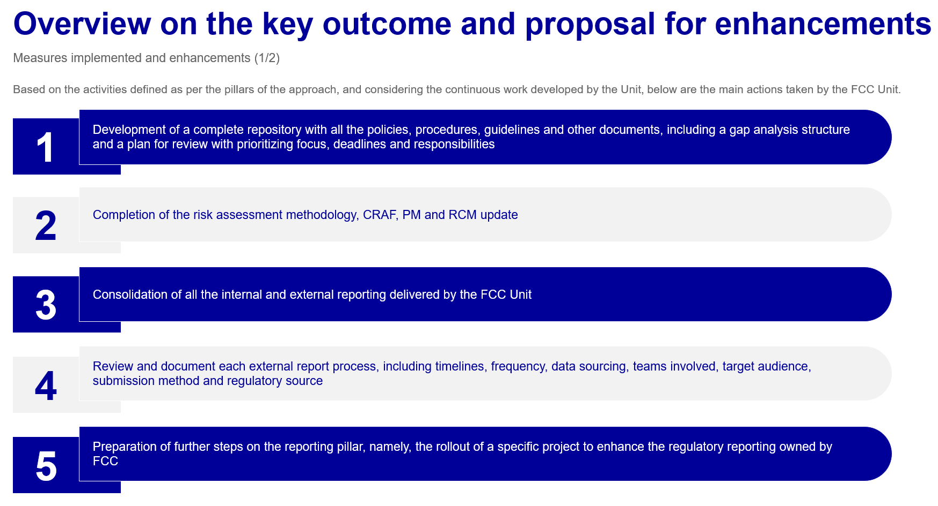
FCC Roadmap_Target Operating Model_vFinal.pptx

- Check the status and completion of the enhancements and verify if they work adequately.
- Assess the regulatory reporting owned by FCC regarding compliance with regulation

CFCL
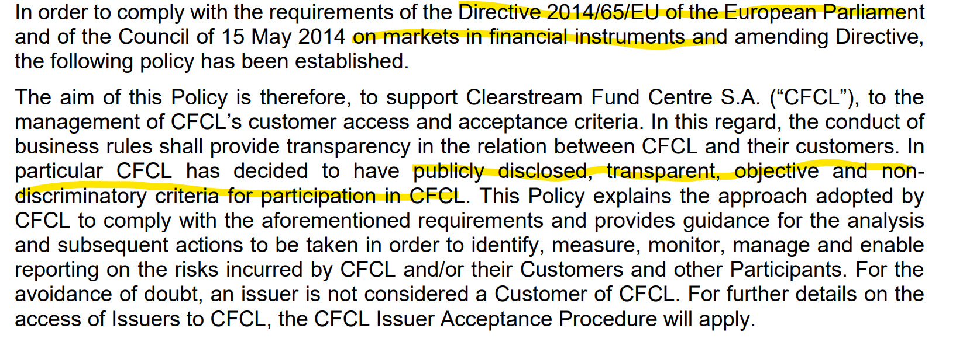
Customer and Access Acceptance Policy v 3.0.pdf

CFCL Customer and Access Acceptance Policy determines the following criteria for becoming a customer of CFCL with eligible counterparties as described in the regulation:
- “MiFID II Customer classification requirement”
- or with institutional clients as described in section “FINSA Customer classification requirement”.

CFCL Policy on the Prevention of Money Laundering & Terrorist Financing
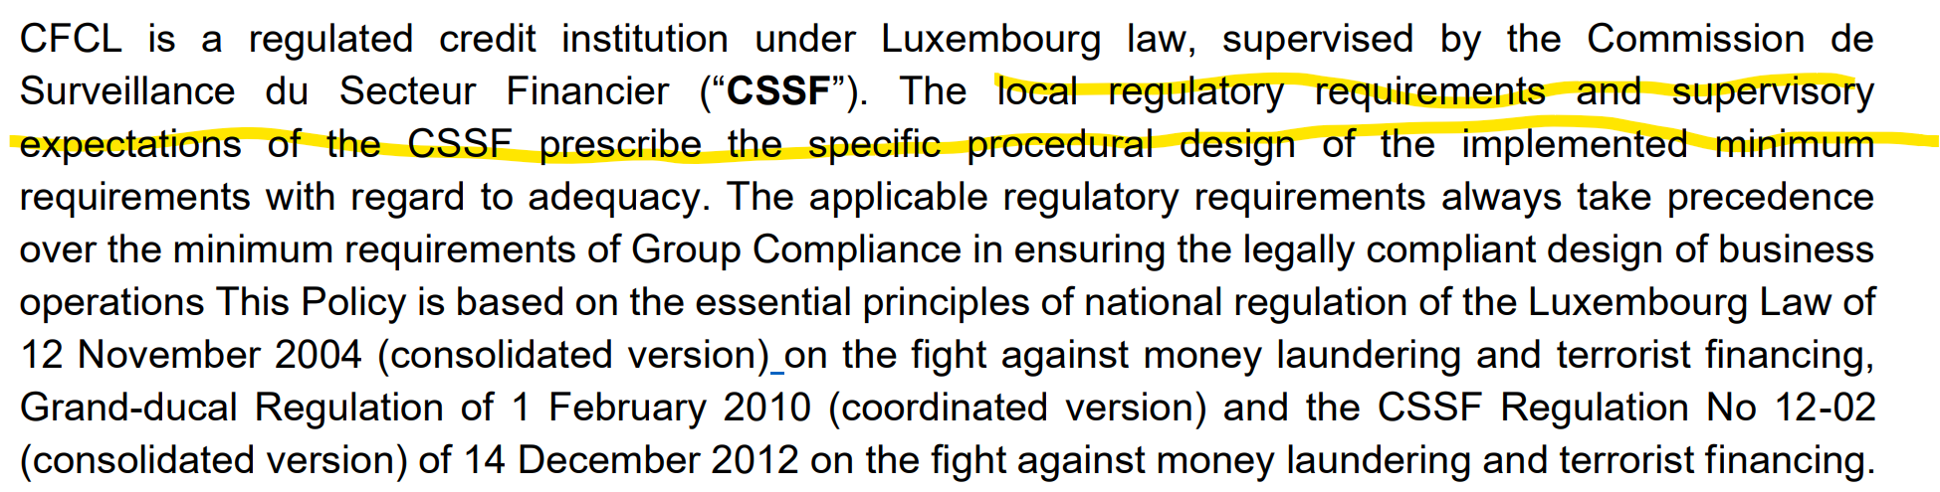
Policy on the Prevention of Money Laundering Terrorist Financing_2024_v4.0_CFCL.pdf

Have we received the following:
- Guideline on the Prevention of Money Laundering & Terrorist Financing - yes Guideline on Prevention of Money Laundering Terrorist Financing.pdf
- General Terms and Conditions of CFCL re procedure for dealing with withdrawal of access to CFCL
- Any monitoring systems in place? No

Scila access
IA will receive certificates that require installation

Deutsche Börse SCILA

ECAG: new release
CBF: tests ongoing; go live should be in October 2025
ExR, CBL: tests ongoing

Anomalies are generated via rules
Anomalies are allocated to a Monitoring Report; it can be one or several anomalies that are grouped together

The L1 Compliance officer performs analysis following decision matrix.
If not resolved, the case is passed on to the L2 Compliance Officer.

Rules administration
- High Risk Customer (HRC): AML Analytics & Monitoring (ZEK) receive a monthly update file from COM that is manually input following 4EP into Scila
- The new release will allow an import functionality that is not yet live
- SAR:
  - AML suspicious customers are monitored for 3 months
  - CTF suspicious customers are monitored for 6 months
  - The system allows a date to be entered so the timeframe can be monitored

Adapter
Part of daily BAU: the data delivery from the source systems is checked for completeness

Expected TPM rules in Scila
IA would expect that at least the following rules are addressed:
- Transaction amount thresholds: Rules to flag transactions above certain high-value thresholds or sudden large transactions relative to customer profile.
- Rapid movement of funds: Detection of rapid movement of funds in and out of accounts, which may indicate layering.
- Complex transaction chains: Identification of convoluted or circular transaction patterns.
- Unusual transaction frequencies: Monitoring unusual spikes or drops in transaction volumes or frequencies.
- Geographic risk: Transactions involving high-risk or sanctioned jurisdictions.
- Customer behaviour anomalies: Transactions inconsistent with the customer’s known profile or past behaviour.
- Structuring/smurfing: Transactions just below reporting thresholds to evade detection.
- Sanction and blacklist hits: Transactions involving parties on sanction lists or politically exposed persons (PEPs).
- Use of new or unusual counterparties: Transactions with new counterparties that do not fit typical patterns.
- Multiple accounts activity: Patterns suggesting connections between multiple accounts controlled by the same individual/entity.
- Time-based patterns: Transactions occurring at unusual times or closely spaced in time.
- Unexplained source of funds: Transactions without clear economic rationale.

L3 Data - Identification of Input Sources, Data Quality Assurance and Internal Reporting

Documents received
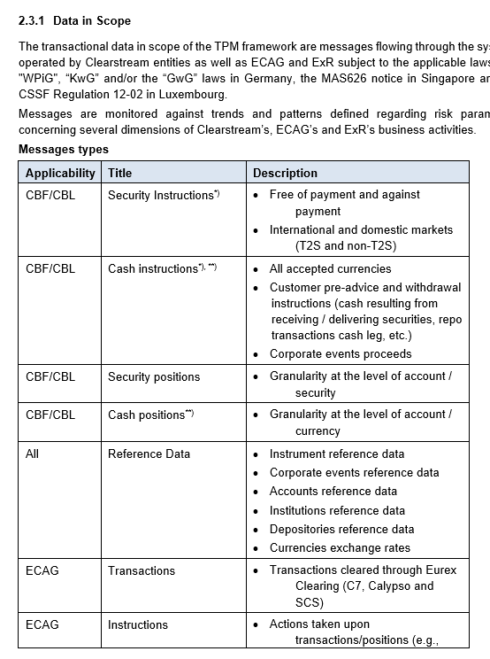
TPM_GOV_Procedure_Oversight.docx

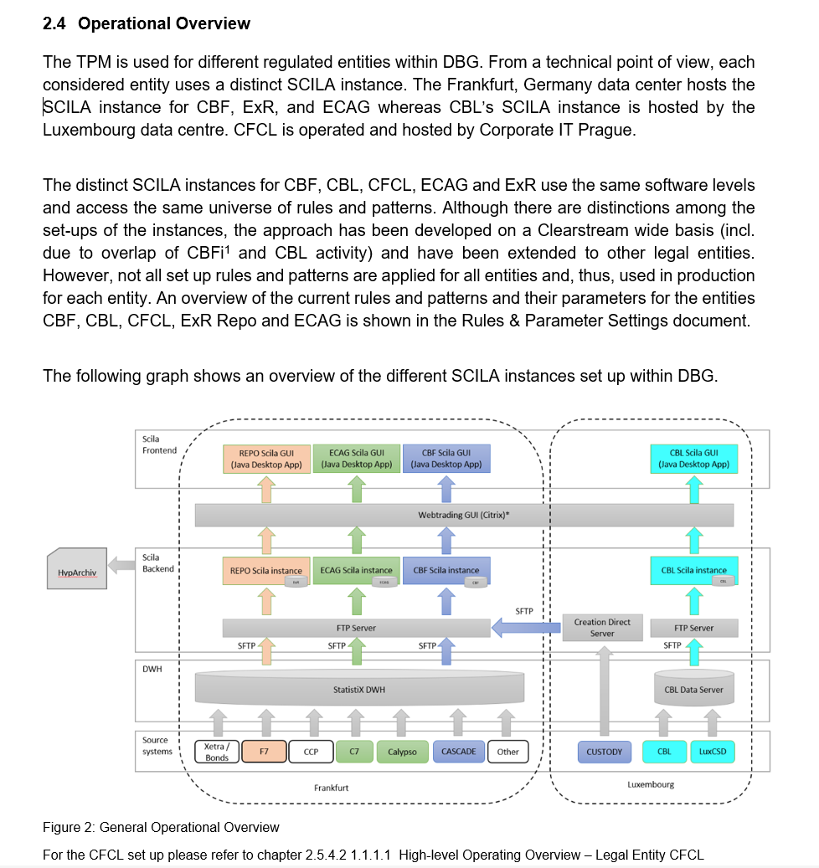
TPM_GOV_Procedure_Oversight.docx

Further details of the Architecture and Infrastructure are documented in the Architecture and Infrastructure document (see chapter 1.3).
Further details of the Interface Specification for each legal entity are documented in the Interface Specification documents (see chapter 1.3).

- What is industry best practice and what analysis was performed?
The Expert Round, which takes place on a quarterly base, serves as an information exchange platform between the 1st line of defence (Business) and Group Compliance (2nd line of defence).

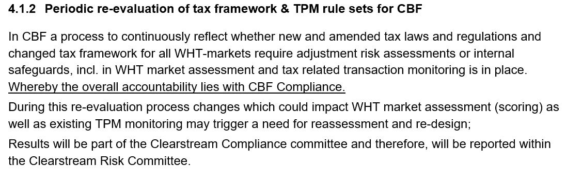
- Anything similar for the other LE?

Currently all relevant data from the ultimate source systems for all TPM instances in Frankfurt are integrated within the data warehouse StatistiX. StatistiX is the only single source of truth for TPM in Frankfurt.
In Luxembourg TPM all input data are integrated within CL Data Server database.
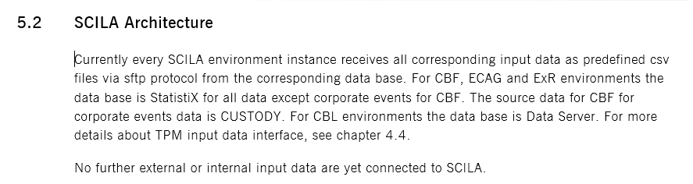
TPM_Architecture and Infrastructure.docx

Questions
- How are tools integrated into the application landscape?
- Which interfaces are used and how?
- What is the contractual relationship between DBAG, Scila and other DBG LE?
- How do you ensure completeness of data messages monitored by Scila from the different source applications?
- How is data protected, i.e. access prevented by Scila itself etc.

Suspicious Transaction Reporting/Suspicious Activity Reporting

Suspicious Transaction Reporting & Suspicious Activity Reporting

L3 Details
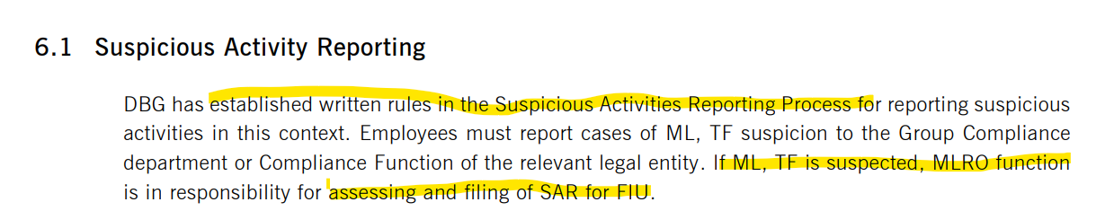
Framework_AML_CTF_OCO.pdf
- Understood as periodic and/or ad hoc monitoring as opposed to continuous monitoring

Should whistleblowing as a channel for SAR be included? Currently it is listed under Regulatory reporting to authorities, however, an investigation etc surely precedes this?

DBAG & GER
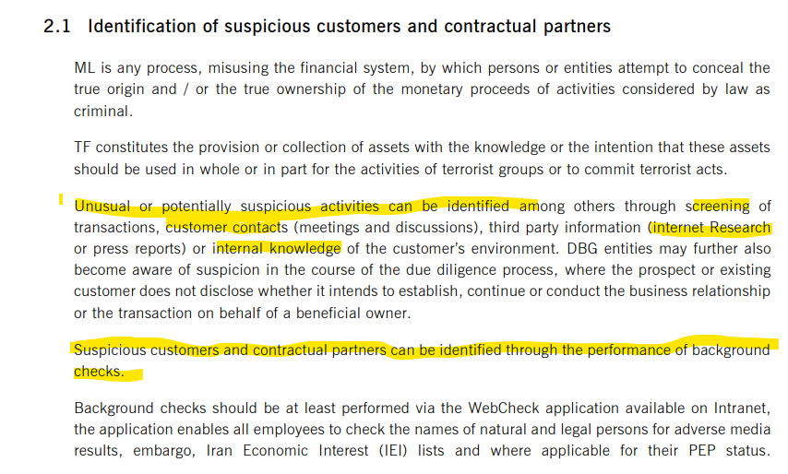
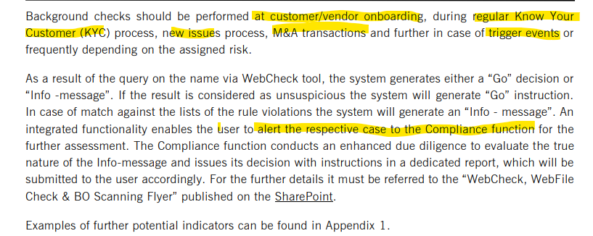
SAR Reporting Process.pdf

- Reporting to GCC? Framework_AML_CTF_OCO.pdf, p 11-12
- How is check against reg. requirement, i.e. GWG section 43(1) performed?
- Have requests for information from the FIU pursuant to section 30 (3) received during the audit period and how were they handled in compliance with rules and reg?
- German entities report electronically via GoAML. How are SARs for non-German entities performed?
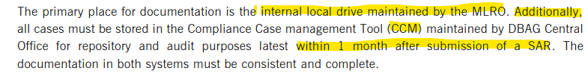
SAR Reporting Process.pdf, Page 10

- For terminated relationships, ensure they were processed in compliance with rules & reg.?

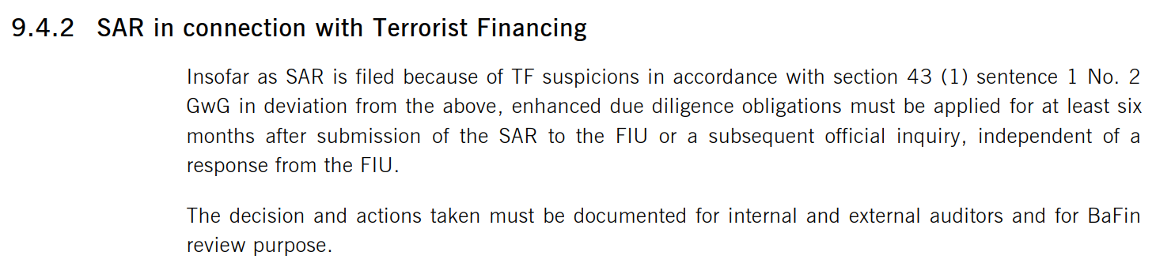
SAR Reporting Process.pdf
- How are 6 month enhanced due diligence performed?

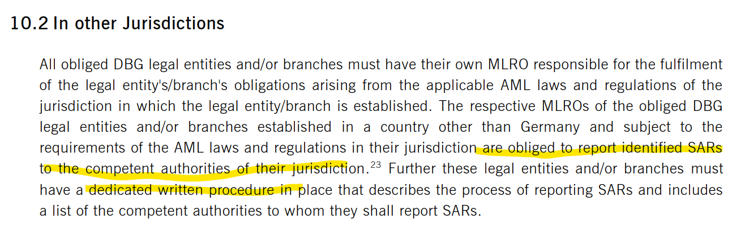
SAR Reporting Process.pdf

Row Labels | Count of CCM Affected Entity
Clearstream Banking AG | 42
Eurex Clearing AG | 62
(blank)
Grand Total | 104
20250818_SAR Overview.xlsx

OverviewHighRiskCountryTransactions_CBF_ExR.xlsx

Clearstream LUX
Dedicated SAR procedure Suspicious Activity Reporting Procedure (1).pdf
- Is this also relevant to CS as no listed?
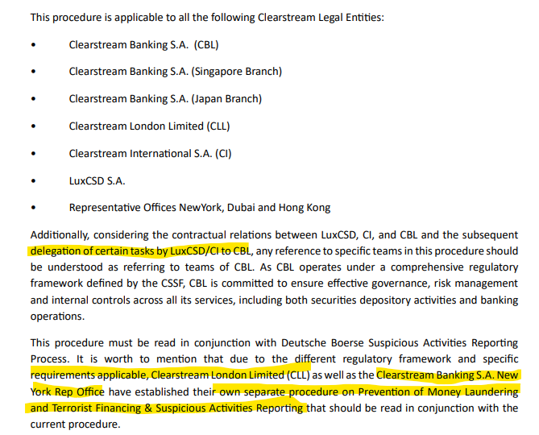
Suspicious Activity Reporting Procedure (1).pdf

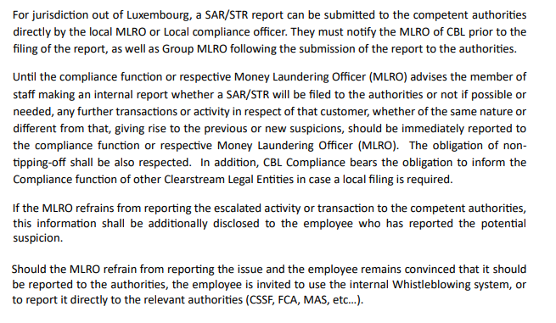
Suspicious Activity Reporting Procedure (1).pdf
- Any requirement to perform enhanced monitoring via TPM?

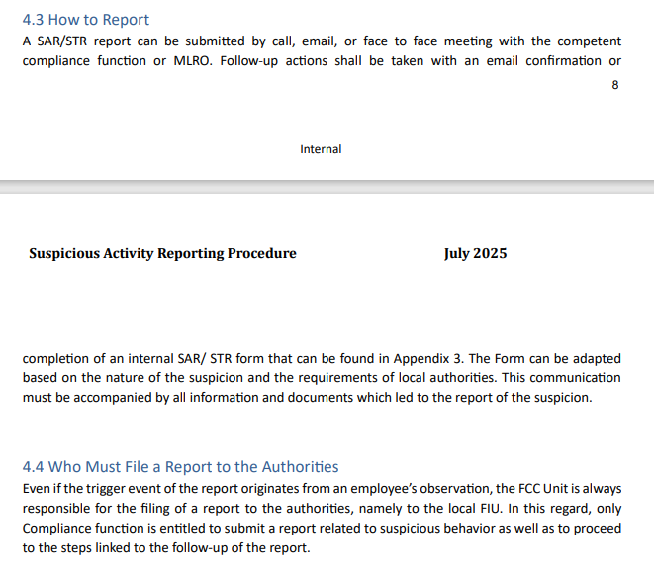
- Any escalation/reporting to the authorities by the individual in case the MLRO does not report?
- Are SAR put on TPM enhanced monitoring?

SAR reporting is performed as follows:
- via GoAML for LUX
- UK via National Crime Agency (NCA) as soon as practicable (what does that mean?); upon approval filing can be done
- Singapore via SONAR portal within 5 business days unless exceptional circumstances; if sanctions relevant 1 business day
- Australia via SMR within
- 24 hours if the suspicion relates to terrorism financing or
- 3 business days if the suspicion relates to money laundering or any other offence

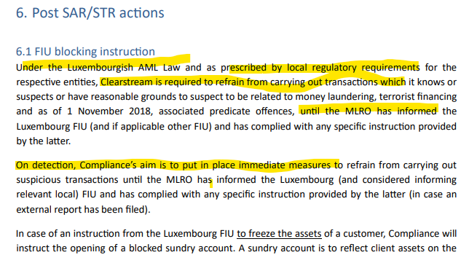

- 10 years of record keeping

Row Labels | Count of REASON FOR FILING
Adverse media | 1
Beneficial ownership issues | 1
Economic background of the account user | 1
Fraudulent transaction | 4
Non-cooperative client & adverse media | 1
Non-respect of AML/TF obligations by client | 1
Open source indications and information | 1
Other | 1
Sanctions | 14
Structuring | 2
Suspicious transaction pattern | 1
Unusual behaviour of the customer | 1
Use of forged documents | 1
(blank)
Grand Total | 30
CBL SAR_TFAR.xlsx

SAR report filed by Clearstream Singapore and UK; data had to be requested by CBL. CBL Singapore.msg and CBL UK.msg

Lack of oversight from CBL side?

CFCL
None

Initiation panel 18/09/2025
The HoIAs confirmed the following:
- one auditor covers all LE; except for AML Risl Analysis (L2 AML Risk Methods)
- branches are in scope for centralised processes, particularly in terms of
  - Oversight
- CH: not listed as an entity in scope on start letter; do not send out the start letter again but keep it as it is and include CH in audit report as individuals are the same than other Clearstream entities

- Any issues/notes/outstanding work will be moved to the subsequent years as part of the 3 year plan

CFCL
IA met with the auditee Iasmina Petac (HoU AML), Cemal Celik, Estelle Thomas on 26/09/2025

IA obtained the following information and asked for further documentation:
- New employees (time they have been with the team): Cemal (6 months), Estelle 1 months
- Scila – contract signed; Technical go live obtained last week, MCP pending
- Contact Alexandra regarding outsourcing
- Iasmina confirmed that there is a project overview and implementation timeline as well as communication to the Board, Committees and the Regulator
- Transfer of accounts started in September 2024 but without settlements; settlements only commenced in 2025

